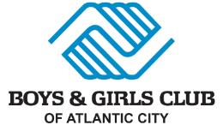
DONOR/PLEDGE FORM
Donor Name(s): _______________________________________________________ _______
Address: _____________________________________________________________________
City/State/Zip: ________________________________________________________________
Email: __________________________________Phone: _______________________________
By signing below, I/we are committing to the following donation/pledge to the Boys & Girls Club of Atlantic City: Amount: _______________________
To be used for: ____General Operations ____ Special Event____ Other
___Transform Campaign:
Naming Opportunity:________________ Area________________________ __________________________________________________________________________
PAYMENT INSTRUCTIONS
____ I will pay the entire pledge on or before ________ (please send me an invoice 2 weeks prior)
____ I would like to be billed in ___installments of $________.
____ Weekly _____ Monthly Beginning on __________
____ Check is enclosed (payable to The Boys & Girls Club of Atlantic City)
____ Please charge my: _____ Visa _____Mastercard ____American Express ____ Discover
Card Number _____________________________ Expires ______CVV Code_____
Name on Card: _____________________________________________________
Billing Address: _____________________________________________________
_____Other method of Payment _______________________________________
CONFIRMATION
Signature _________________________________________ Date_________
Print Name ________________________________________

